**Job finder Role:**

Apply Jobs – This feature allows job seekers to apply for jobs without delay through the app. Users can search job listings primarily based on their options. And he/she can also apply by selecting the job category.

Applied Job Management - Users can edit or delete their apps on their profile. Cancel their application if they want to make any changes or if they are no longer interested in the job.

Send Inquiry – User can directly ask their problems through inquiry section. If user have application issue or want about any information’s they can use it.

Tracking application – When user applied any job through our app automatically counts the number of jobs the he/she has applied through our app. This functionality giving an overview of their applications.

**Screenshots:**

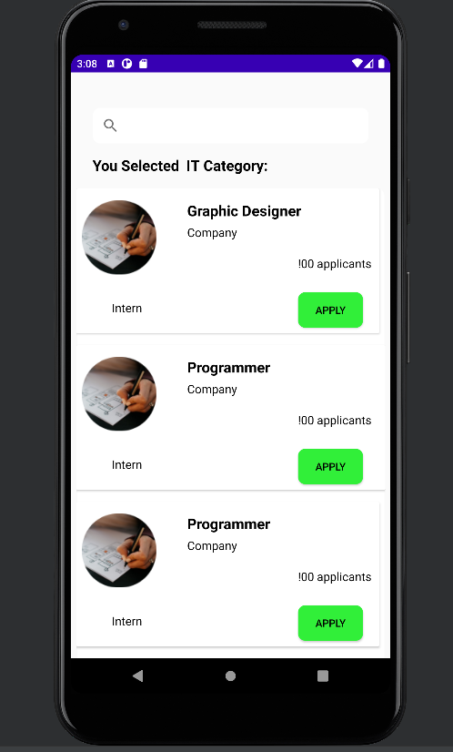

Job List View

*Searchbar Dimensions*

android:layout_width="373dp"  
android:layout_height="48dp"  
android:layout_marginStart="32dp"  
android:layout_marginTop="32dp"  
android:layout_marginEnd="32dp"

*Category Dimensions*

android:layout_width="374dp"  
android:layout_height="53dp"  
android:layout_marginStart="24dp"  
android:layout_marginTop="16dp"  
android:layout_marginEnd="24dp"

*CardView Dimensions*

android:layout_width="match_parent"  
android:layout_height="wrap_content"  
android:layout_marginLeft="8dp"  
android:layout_marginEnd="8dp"

*image Dimension*

android:layout_width="wrap_content"  
android:layout_height="wrap_content"  
android:layout_marginStart="8dp"  
android:layout_marginTop="16dp"

*Title Dimension*

android:layout_width="170dp"  
android:layout_height="38dp"  
android:layout_marginStart="150dp"  
android:layout_marginTop="16dp"

android:textSize="20sp"

*company name Dimension*

android:layout_width="wrap_content"  
android:layout_height="wrap_content"  
android:layout_marginStart="150dp"  
android:layout_marginTop="48dp"

android:textSize="16sp"

*Other text Dimension (intern and count applicants)*

android:layout_width="wrap_content"  
android:layout_height="wrap_content"  
android:layout_gravity="clip_vertical"  
android:layout_marginStart="48dp"  
android:layout_marginTop="150dp"  
android:layout_marginBottom="24dp"

android:textSize="16sp"

*Button Dimension*

android:layout_width="wrap_content"  
android:layout_height="wrap_content"  
android:layout_marginStart="300dp"  
android:layout_marginTop="140dp"

*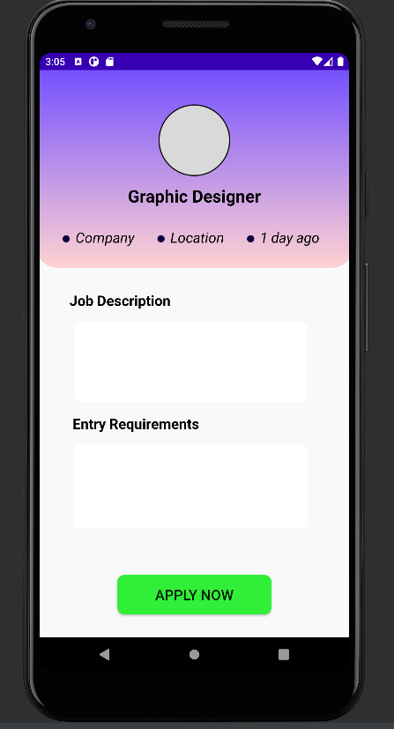Job view page*

*image Dimension*

android:layout_width="100dp"  
android:layout_height="100dp"  
android:layout_marginTop="48dp"  
app:layout_constraintEnd_toEndOf="parent"  
app:layout_constraintStart_toStartOf="parent"

*Text Dimension (job title ,company, time)*

android:layout_width="wrap_content"  
android:layout_height="wrap_content"  
android:layout_marginStart="8dp"  
android:layout_marginTop="220dp"

android:textSize="20sp"

*Job name Dimension*

android:layout_width="330dp"  
android:layout_height="39dp"  
android:layout_marginStart="32dp"  
android:layout_marginTop="8dp"  
android:layout_marginEnd="32dp"

android:textSize="24sp"

*Job description Dimension*

android:layout_width="wrap_content"  
android:layout_height="wrap_content"  
android:layout_marginStart="8dp"  
android:layout_marginTop="32dp"  
android:layout_marginEnd="60dp"

*Entry Requirements Dimension*

android:layout_width="wrap_content"  
android:layout_height="wrap_content"  
android:layout_marginTop="16dp"

android:textSize="20sp"

*Apply Button Dimension*

android:layout_width="215dp"  
android:layout_height="55dp"  
android:layout_marginBottom="32dp"

android:textSize="20sp"

*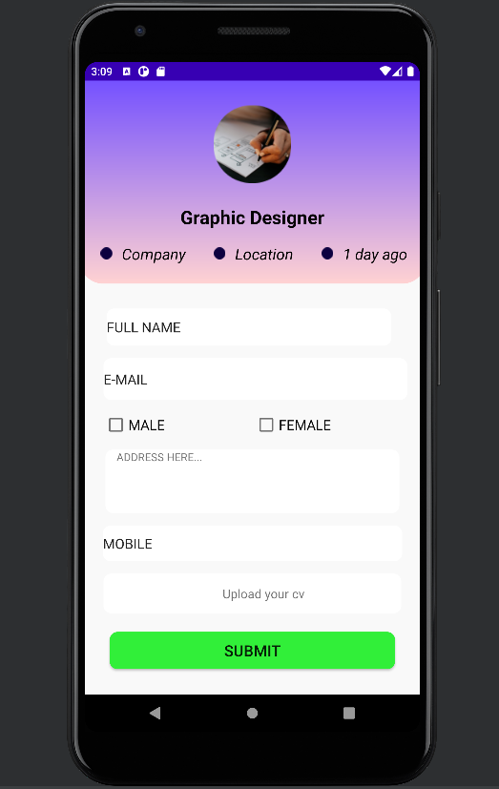Application Form page*

*Form text Dimension*

android:layout_width="367dp"  
android:layout_height="48dp"  
android:layout_marginStart="24dp"  
android:layout_marginTop="32dp"  
android:layout_marginEnd="24dp"

*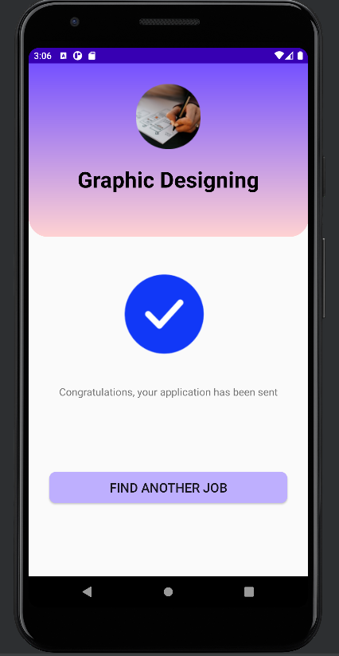Application Sent Success Page*

*Reply msg Dimension*

android:layout_width="wrap_content"  
android:layout_height="wrap_content"  
android:layout_marginTop="16dp"

android:textSize="16sp"

*Button Dimension*

android:layout_width="367dp"  
android:layout_height="48dp"  
android:layout_marginStart="24dp"  
android:layout_marginTop="32dp"  
android:layout_marginEnd="24dp"

*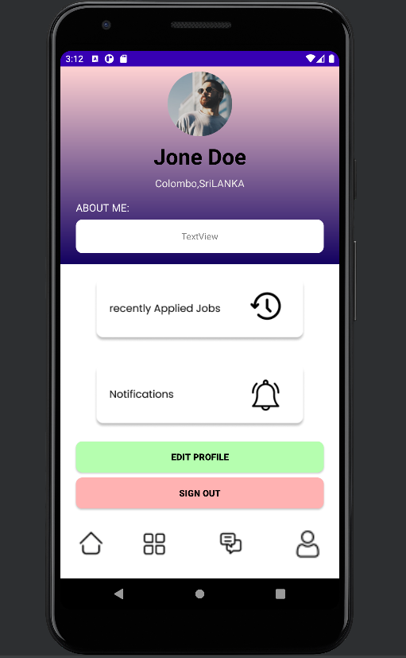Seeker Profile Page*

*Profile image dimension*

android:layout_width="100dp"  
android:layout_height="100dp"  
android:layout_marginTop="8dp"

*Name Dimension*

android:layout_width="wrap_content"  
android:layout_height="wrap_content"  
android:layout_marginTop="8dp"

android:textSize="34sp"

*Location Dimension*

android:layout_width="wrap_content"  
android:layout_height="wrap_content"  
android:layout_marginTop="8dp"

android:textSize="16sp"

*About me dimension*

android:layout_width="match_parent"  
android:layout_height="wrap_content"  
android:layout_marginStart="24dp"  
android:layout_marginTop="16dp"  
android:layout_marginEnd="24dp"

android:textSize="16sp"

*Text view Size*

android:layout_width="384dp"  
android:layout_height="52dp"  
android:layout_marginStart="24dp"  
android:layout_marginTop="8dp"  
android:layout_marginEnd="24dp"

*Recently applied button and notification button Dimensions*

android:layout_width="359dp"  
android:layout_height="126dp"  
android:layout_marginTop="8dp"

*Edit and sign out button Dimensions*

android:layout_width="match_parent"  
android:layout_height="wrap_content"  
android:layout_marginStart="24dp"  
android:layout_marginTop="8dp"  
android:layout_marginEnd="24dp"

android:textSize="14sp"

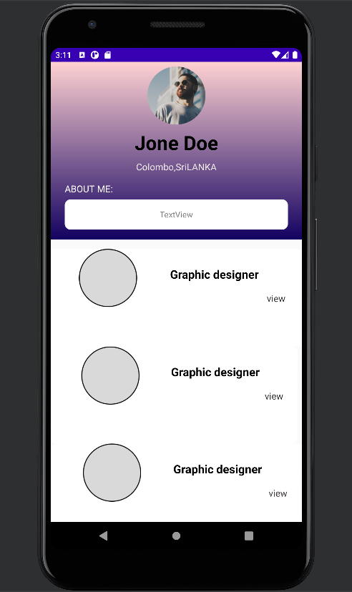

*Recent Job ViewList Page*

*Image Dimensions*

android:layout_width="wrap_content"  
android:layout_height="100dp"  
android:layout_weight="1"

*Title dimension*

android:layout_width="wrap_content"  
android:layout_height="wrap_content"  
android:layout_marginTop="30dp"  
android:layout_weight="1"

android:textSize="20sp"

*View dimension*

android:layout_width="wrap_content"  
android:layout_height="wrap_content"  
android:layout_marginTop="70dp"  
android:layout_marginRight="16dp"  
android:layout_weight="1"

android:textSize="16sp"

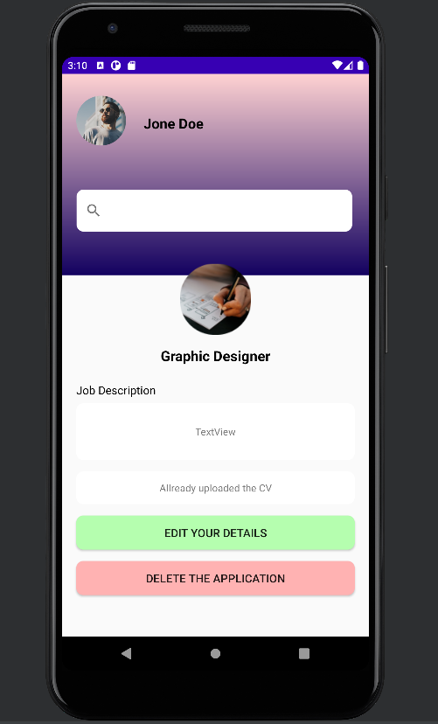

*Recent Applied Job Page*

*Image dimension*

android:layout_width="wrap_content"  
android:layout_height="wrap_content"  
android:layout_marginTop="8dp"

*Title Dimension*

android:layout_width="wrap_content"  
android:layout_height="wrap_content"  
android:layout_marginTop="16dp"

android:textSize="20sp"

*Job description Dimension*

android:layout_width="wrap_content"  
android:layout_height="wrap_content"  
android:layout_marginTop="24dp"

android:textSize="16sp"

*Text View Dimension*

android:layout_width="match_parent"  
android:layout_height="80dp"  
android:layout_marginStart="16dp"  
android:layout_marginTop="8dp"  
android:layout_marginEnd="16dp"

*Edit and Delete Dimension*

android:layout_width="match_parent"  
android:layout_height="wrap_content"  
android:layout_marginStart="16dp"  
android:layout_marginTop="16dp"  
android:layout_marginEnd="16dp"

android:textSize="16sp"